Grade Assist Telltale – CGEA1.3

Functional Description

The purpose of the Grade Assist telltale is to inform the driver that the automatic transmission is in the Grade Assist mode.

The Grade_Assist_Telltale correlates the PtDrvMde_D_Stat signal and the Operational_Mode to illuminate or extinguish the Grade Assist telltale.

The Grade Assist telltale shall provide an iconic representation that will illuminate or extinguish to inform the driver transmission will not shift into overdrive gear on an automatic transmission.

Note: PtDrvMde_D_Stat signal same value is also used to activate the Tow Haul Telltale. To date no programs have or are expected to have both the Grade Assist and Tow Haul features. If this ever occurs, however, unique appliques with appropriate symbol controlled by unique IPC part numbers. 2 separate telltales with EOL or Internal Supplier Config bit will have to be employed.

Interfaces

Interface Context Diagram (I/O Block Diagram)
Figure 1. Grade Assist Telltale Indication
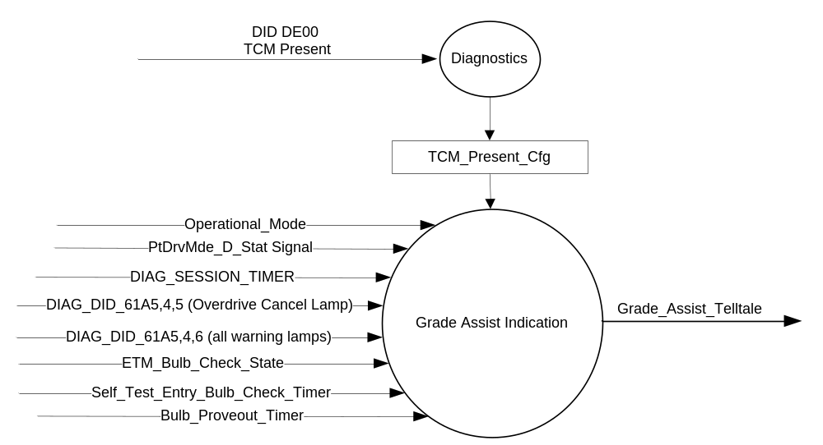

Inputs
      - INTERNAL:
            - DIAG_SESSION_TIMER
            - Operational_Mode
            - DIAG_DID_61A5,4,5 (Overdrive Cancel Lamp)
            - DIAG_DID_61A5,4,6 (All warning Lamps)
      - MUX message on the CAN Bus

- PtDrvMde_D_Stat Signal
Signal Name | Size  (bits) | Detail | Units | Res. | Offset | State  Encoded | Min. | Max.
PtDrvMde_D_Stat | 3 |  | SED | 1 | 0 |  | 0  (0x0) | F  (0xF)
 |  | Normal |  |  |  | 0x0
 |  | Sport |  |  |  | 0x1
 |  | SnowWet |  |  |  | 0x2
 |  | TowHaulGradeAssist |  |  |  | 0x3
 |  | NotUsed1 |  |  |  | 0x4
 |  | NotUsed2 |  |  |  | 0x5
 |  | NotUsed3 |  |  |  | 0x6
 |  | NotUsed4 |  |  |  | 0x7
 |  | NotUsed5 |  |  |  | 0x8
 |  | NotUsed6 |  |  |  | 0x9
 |  | NotUsed7 |  |  |  | 0xA
 |  | NotUsed8 |  |  |  | 0xB
 |  | NotUsed9 |  |  |  | 0xC
 |  | NotUsed10 |  |  |  | 0xD
 |  | NotUsed11 |  |  |  | 0xE
 |  | Faulty |  |  |  | 0xF

Outputs
Grade_Assist_Telltale, which is used to control the state of the LED

Function/Performance

Operational Modes

Mode | Differentiating Vehicle Conditions
Sleep Mode | Grade_Assist_Telltale Inactive
Limited Mode | Grade_Assist_Telltale Inactive
Normal Mode | Grade_Assist_Telltale Active/Inactive
Crank Mode | Grade_Assist_Telltale Active/Inactive

Voltage Levels

Refer to the Cluster Features table located in the Operational Modes and Voltage Range Strategies Section in this SPSS

Human-Machine Interface

Visual

Indicator Graphics / Display Format
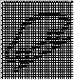
Passenger Car SUV

For actual symbol definition refer to database # K.917 of the 03-0685 ARL requirement.

Indicator Color Coordinates

Amber - Reference SDS IL-0017/IS-0379

Indicator Characteristics

LED – Grade Assist Telltale

Audio

None

Switch Control Logic

Not Applicable

System Accuracy

The state of the Grade_Assist_Telltale shall change within 100msec of a state change as indicated in the state matrix reference 1.3.5.1 Subsystem Algorithm Flowchart/ State Diagram

Operation: Performance and Functional

Subsystem Algorithm Flowchart / State Diagram

- State Matrix for Grade_Assist_Telltale
Operational_ Mode | ETM Bulb_ Check_  State | DIAG_SESSION  _TIMER | Self_Test_ Entry_Bulb_ Check_  Timer | DIAG_DID_  61A5,4,5  (Overdrive Cancel Lamp) | DIAG_DID_  61A5,4,6  (all warning lamps) | Bulb_  Proveout_  Timer | PtDrvMde_D_Stat  Signal | Grade_Assist_ Telltale
Normal or Crank | X | Not Active | X | X | X | Active | X | ON
Normal or Crank | X | Not Active | X | X | X | X | TowHaulGradeAssist (0x3) | ON
Normal or Crank | ON (0x1) | Not Active | X | X | X | X | X | ON
Normal | OFF (0x0) | Not Active | X | X | X | X | Missing as per 1.4.1 | OFF
Normal | X | Active | Not Active | Not Received | Not Received | X | TowHaulGradeAssist (0x3) | ON
Normal | X | Active | X | ON (0x1) | X | X | X | ON
Normal | X | Active | X | X | ON (0x1) | X | X | ON
Normal | X | Active | Active | X | X | X | X | ON
Normal | ON (0x1) | Active | X | X | X | X | X | ON
All Other Cases |  |  |  |  |  |  |  | OFF
X = Don’t Care
Not Received = The state when a DIAG_SESSION_TIMER is active and the DID has not been received.

Operation Description (supports algorithm flowchart /state diagram)

- Grade_Assist_Telltale shall reflect signal state within 100 mS of receipt of PtDrvMde_D_Stat Signal.

Function Safety Classification (EMC)

Class B

Memory Storage

Parameter Name | Description | Value at  Battery Connect | Value at  Module Wake-up
Grade_Assist _Telltale | Used to control the state of the RTT | Not Active (0x0) | Not Active (0x0)
PtDrvMde_D_Stat signal | CAN signal sent from the TCM | Normal (0x0) | Normal (0x0)
TCM_Present_Cfg | Encoded indicator of feature presence controlled via CAN at EOL at VO plant. | Use Stored Value | Use Stored Value
ETM_Bulb_Check_State | State indicator for warning bulb in ETM | OFF (0x0) | OFF (0x0)
DIAG_DID_61A5,4,5 (Overdrive Cancel Lamp) | Warning Lamp Status 2, byte 4, bit 5 (Overdrive Cancel Lamp) | 0 (0x0) | 0 (0x0)
DIAG_DID_61A5,4,6  (All warning Lamps) | Warning Lamp Status 2, byte 4, bit 6  (All warning Lamps) | 0 (0x0) | 0 (0x0)
Operational_Mode | 4 state indicator for cluster operational mode | Limited | Limited or Normal or Crank

Parameter Name | Description | Value at Battery Connect | Value at Module Wake-up
Self_Test_Entry_Bulb_Check_ Timer | Timer used in diagnostic session to do a self check of telltales | Not Active | Not Active
DIAG_SESSION_TIMER | Timer used to time-out a diagnostic session | Not Active | Not Active

Prove Out

Yes

Reconfigurable Telltale

No

Message Center Msg

None

Error Handling

Missing Message Strategy
The signals will be declared missing as per the Diagnostics section of this SPSS.

DTCs states and history will be determined as per the Diagnostics section of this SPSS.

Depending on the B&A configuration, only one of the missing message DTCs shall be logged given the proper input conditions.

Diagnostics

Self Test

Bulb illuminated during self test as per Self_Entry_Bulb_Check_Timer

Engineering Test Mode

Reference section “Dealer / Engineering Test Mode (ETM)”

Part II Performance

Supported Diagnostic DIDs (Service $22 and $2F)
Number | DID / CommonID Name | DID Type
DIAG_DID_61A5,4,5 (Overdrive Cancel Lamp) | Warning Lamp Status 2, byte 4, bit 5 (Overdrive Cancel Lamp) | Bit Mapped
DIAG_DID_61A5,4,6  (All Warning Lamps) | Warning Lamp Status 2, byte 4, bit 6 (All Warning Lamps) | Bit Mapped

Supported Diagnostic Trouble Codes (DTCs)
DTC | Description
C10000 | Lost communication with ECM/PCM
C10100 | Lost communication with TCM

DID DE00
Block  Num | Block Description | Size (bits) | Type | Byte(s) | Bits | State: Description | "0" | "1" | Default | Comments/  Information
PACKETED BLOCKS
$00 | Option Content (B&A) | * | 1 | * | * | TCM Present | Disabled (PCM) | Enabled | Enabled
*Byte and bit location to be identified in Part II Specification for this cluster

Reference Specification

IS-0001 WARNINGS/INDICATORS/DISPLAYS PROVEOUT
IS-0046 INSTRUMENTATION MATERIAL RESISTANCE TO CLEANING
IS-0052 OPERATING VOLTAGES - FUNCTIONAL/PERFORMANCE
IS-0069 FUNCTIONAL IMPORTANCE CLASS
IS-0324 WINDSHIELD & OTHER REFLECTIONS
IS-0327 WARNING INDICATOR EVALUATION
IS-0329 FLICKERING OF LAMPS
IS-0379 NORTH AMERICAN WARNINGS AND INDICATORS STRATEGY

IL-0017 TELLTALE AND INTERIOR ILLUMINATION COLOR
IL-0021 CRAFTSMANSHIP - DISPLAYS
IL-0023 CLARITY/LEGIBILITY/READABILITY
IL-0025 INTERIOR ILLUMINATION INTENSITY
IL -0027 VISUAL CONTRAST
IL -0043 OPERATIONAL ENVIRONMENT FUNCTIONALITY
IL -0045 COLOR
IL -0047 TELLTALE; INDICATOR AND DISPLAY LIGHT INTENSITY
IL -0048 ILLUMINATION ACCEPTABILITY

03-0661 PLACEMENT: CONTROL AND DISPLAY LOCATIONS
03-0662 PLACEMENT: LOGICAL GROUPING FUNCTION AND USAGE
03-0664 PLACEMENT: DOWN VISION TO COMPONENTS WITH HIGH VISUAL DEMAND
03-0665 PLACEMENT: EXPECTED LOCATIONS OF CONTROLS AND DISPLAYS VDS
03-0670 INTERIOR VISIBILITY
03-0671 INTERIOR VISIBILITY: REFLECTIONS FROM COMPONENTS & SURFACES
03-0672 INTERIOR VISIBILITY: REFLECTIONS IN DISPLAYS
03-0673 INTERIOR VISIBILITY: VISUAL OBSCURATIONS
03-0674 INTERIOR VISIBILITY: ILLUMINATION CONTROLS / DISPLAYS
03-0675 INTERIOR VISIBILITY: VEILING GLARE
03-0677 INTERIOR VISIBILITY: SUNLIGHT WASHOUT
03-0681 IDENTIFICATION: CHARACTER AND SYMBOL SIZE
03-0682 IDENTIFICATION: LEGIBILITY
03-0685 IDENTIFICATION: SYMBOLS, ABBREV FOR CONTROL
03-0721 LOGIC OF OPERATION: OPERATIONAL STEREOTYPES
03-0722 LOGIC OF OPERATION: INTERPRETATION
03-0723 LOGIC OF OPERATION: USE OF SYSTEMS WITH VISUAL DISPLAYS

Revision History

SPSS Module Revision History

Revision Level | Name | Change Description | Date
1.0 | V. Patel | Updated for Grade Assist Telltale CGEA 1.3 based on Grade Assist RTT CGEA1.3 STSS v1.0  Section 1.2.1, Figure 1 – Added diagnostic and ETM inputs  Section 1.3.5, Table 1.1 – Added columns to capture diagnostic and ETM input processing. | 6/30/2010
2.0 | J. Blatchford | This update changes the activating signal from TrnShifMde_D_RqDrv to PtDrvMde_D_Stat. If a program uses TrnShifMde_D_RqDrv signal for the Grade Assist feature then use v1.0 of this STSS.  - 1.1: Added paragraph stating same signal and signal value is also used to illuminate the Tow Haul Telltale. If a program is equipped with both Tow Haul and Grade Assist this STSS special actions must be taken.  - Changed TrnShifMde_D_RqDrv to PtDrvMde_D_Stat throughout document.  - Table 1.0: Replaced prior table with proper signal.  - Table 1.1: updated signal and signal value/detail. Corrected missing to missing as per 1.4.1. Removed TCM_Present_Cfg column as that configuration is not used in the logic it is only used to insure the correct DTC is set for missing message.  Changes highlighted in yellow. | 5/21/15

